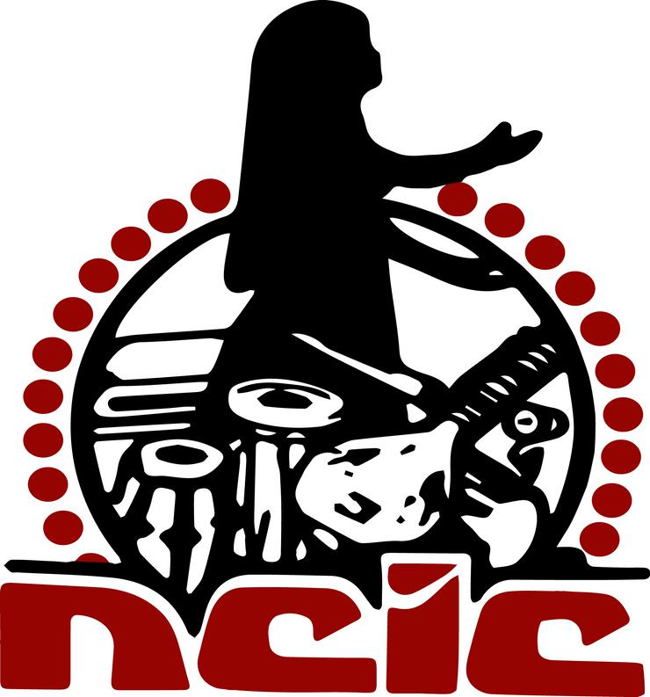

NATIONAL COUNCIL OF INDIAN CULTURE
HERITAGE CENTER
FIRST INTERNATIONAL PHAGWA CONFERENCE 2021
Phagwa in the Global Village:
Traditions, Innovations and Future Developments
FIPC2021
NCIC Nagar, 28-38 Narsaloo Ramaya Marg, Endeavour, Chaguanas 502128, Trinidad, W.I.

Tel/Fax: (868) 671-6242 / 789-9101 Email: phagwafipc2021@gmail.com; pgoopta@hotmail.com;

Website: http://www.ncictt.com

CONFERENCE PANELS : 13-14 MARCH 2021

CONFERENCE ZOOM LINK : http://phagwa.ncictt.com/

PLEASE FIND BELOW THE PANELS FOR THE CONFERENCE.

Kindly note that the times for the panels are noted in local (Trinidad) time and Greenwich Mean Time (GMT)

NAMES | ITEM | TIME  LOCAL TIME  (hrs GMT)
SATURDAY 13 MARCH 2021 | OPENING CEREMONY  - Deoroop Teemal (Chairman, NCIC Heritage Center)  - Dr. Deokinanan Sharma (President, NCIC)  - Guest Speaker To be confirmed  - Dr.Primnath Gooptar | 8.00 am—8.30 am  (12:00-12:30 hrs GMT)
SATURDAY 13 MARCH 2021 | PANEL PRESENTATIONS  SEVEN PANELS  FILM NIGHT | 8.30 am— 5.00 pm  (12:30—21.00 hrs GMT)  5.00 pm  ( 21.00 hrs GMT)
SUNDAY 14 MARCH 2021 | PANEL PRESENTATIONS | 8.00 am.--  (12.00 hrs GMT)
DAY ONE | 13 MARCH 2021
NAMES | PAPER | COUNTRY OF ORIGIN | TIME
PANEL 1  Phagwa :Historical Perspectives |  |  | LOCAL TIME  (GMT)  8. 30 am-10.00 am  (12:30—14:00 hrs GMT)
CHAIR: BRINSLEY SAMAROO  (TRINIDAD) | Introduction of presenters by chairman
Sanobar Haider | Phagwa and Awadh’ | Assistant Professor, Department of History, Maharaja Bijli Pasi Government PG College, Lucknow.
Gargi Bhattacharya | Vasantotsav (Spring Festival) in Bengali Culture: Celebration and Philosophy | Assistant Professor, Department of Sanskrit, Pali & Prakrit, Visva, Bharati (A Central University), Santiniketan, West Bengal, India
Primnath Gooptar | The revival of the Phagwa festival in Trinidad : The roles of the Hindu Jawaan Sangh and the Sanatan Dharma Maha Sabha | University of the West Indies/NCIC Trinidad
Satish Prakash | Phagwah and its Observance | New York City and Guyana
Keshwar Ramkissoon | Legends of Holi | Guyana)
QUESTION AND ANSWER SESSION
PANEL 2  Developing trends in the Phagwa Festival in India and the Indian Diaspora. |  |  | 10.05 pm- 11.20 pm  (14.05 --15.20 hrs GMT)
CHAIR: KIRAN CHUTTOO-JANKEE (MAURITIUS) | Introduction of presenters by chairman | .
Nisha Ramracha | The Cultural Appropriation, Secularization, Sacrilege, Desecration and Desacralisation of Phagwa (Holi) | classical archaeologist New York City
Neha Singh | Re-awakening of Indian Diaspora’s Cultural Heritage: Understanding Phagwa as Carnivalesque Setting | Senior Academic Officer, IL & FS Education and Technology, Noida, India
Pt. Jaidath Maharaj  . | Topic: Non-traditional presentations and celebrations of the festival using technology | SWAHA Inc. Trinidad.
Ranjana Krishna | Rethinking Phagwa in Classical Traditions and Modern Times  (A study with special reference to Hindustani Literature in Awadh region) | Associate Professor of English Avadh Girls’ P.G. College, University of Lucknow, UP, India
QUESTION AND ANSWER SESSION
PANEL 3  Developing trends in the Phagwa Festival in India and the Indian Diaspora. |  |  | 11.25 pm- 12.40 pm  (15.25 --16.40 hrs GMT)
CHAIR: RANJANA KRISHNA (INDIA) | Introduction of presenters by chairman | .
Doolarchan Hanoomansingh | Phagwa in Trinidad and The Indo-Trinidadian middle-class | ICDN Trinidad
Pawan K. Upadhyaya | Similarities of Holi in Guyana and India | journalist India
Vishnu Bisram | Introduction and Evolution of Phagwah Celebrations in Guyana | USA
Ariti Jankie | The Importance of preserving the PHAGWA tradition. | Trinidad
QUESTION AND ANSWER SESSION

PANEL 4  Portrayal of Phagwa in the literature, film, art, media and other fora |  |  | 12.45pm —2.00 pm  (16.45 –18.00 hrs GMT)
CHAIR:MANPREET KAUR ( FIJI ) | Introduction of presenters by chairman | University of The West Indies, St. Augustine, Trinidad
Nirvana Persad | Phagwa and East Indian Identity in the West Indies | Sant Nagar Hindu Temple ,Sangre Grande Phagwa Committe
Amita Esther David | Keeping Phagwa alive in a cosmopolitan world | Associate Professor, Department of History, Isabella Thoburn College, Lucknow
Ishita Sen | Bhang as a ‘gateway’ to study the ‘carnival’ of Phagwa | Sub-editor for Benefactory Ventures’ Volv Media. Kolkata, India
Neha Tripathi | Myriads of Cultural Cosmos : A Brief overview of Similarities between Chinese New Year and Phagwah Festival | research scholar University of Lucknow, Uttar Pradesh
QUESTION AND ANSWER SESSION

PANEL 5  Portrayal of Phagwa in the literature, film, art, media and other fora. |  |  | 2.05pm – 3.20 pm (18.05 –19.20 hrs GMT)
CHAIR: DEOROOP TEEMAL (TRINIDAD) | Introduction of presenters by chairman
Shruti Srivastava | Representation of `Phagwa in Indian Literature | Sr. Assistant ProfessorDepartment of English D. A-V. College, Kanpur
Kumar Mahabir | Is Shakespeare’s Macbeth based on a Phagwa legend? | Indo-Caribbean Cultural Centre Co. Ltd (ICC),Trinidad
Megha Choudhary | Fagwa Through Art and Culture of Rajasthan | Research scholar in Department of English from Mohanlal Sukhadia University, Udaipur.
Nutan Ragoobir | An analysis of the portrayal of Phagwa as seen in various forms of literature, festivals and film. | Trinidad
QUESTION AND ANSWER SESSION

PANEL 6  YOUTH ROUND TABLE | KAL, AAJ AUR KAL (Yesterday, today and Tomorrow)  Youth Perspectives for Phagwa in the Diaspora |  | 3.25 pm –5.00 pm (19.25- 21.00 hrs GMT)
CHAIR: VISHAM BHIMULL (TRINIDAD) | Introduction of presenters by chairman
India :…………………………………  Mauritius:……………………..  Guyana:…………………………  Suriname:………………………  Trinidad and Tobago:………  USA:……………………………… | Aayushee Garg  Anjali Tiwari  Roudraksh Jankee  Praem Ramharak  Sejal Bhojwani  Daveanan Ramsaran;  Shiva Daniel  Nisha Ramracha
FILM SESSION |  |  | 5.00 pm  (21.05 hrs GMT)
CHAIR: JAIDATH MAHARAJ  (TRINIDAD) | Introduction of films
Maggie Griffith Williams | Pichakaree: The voice of a people | Northeastern University,  Boston, Massachusetts, USA
Referred by Anjali Singh (taken from Utube) | Lathmar Holi Festival: Novel Tradition of Barsana. | Holi is the festival of colours. In Barsana and Nandagaon, people celebrate a variation called ‘Lathmar Holi’, which means ‘Holi in which people hit with sticks’.  During the festival, women of Barsana, the birth place of Hindu Goddess Radha, beat the men from Nandagaon, the hometown of Hindu God Krishna.
DAY TWO | 14 MARCH 2021
PANEL 7  India Round Table | KAL , AAJ AUR KAL  Phagwa in the different states in India |  | 8.00 am —9.30 am  (12.00 –13.30 hrs GMT)
CHAIR: ARCHANA TEWARI  (INDIA) | Introduction of presenters by chairman
New Delhi  Uttar Pradesh  Bengal  Karnataka  Bihar  Baneras  Rajasthan  Kanpur | Amba Pande  Dr Ranjana Krishna Dr.Amita Esther David  Dr.Sanobar Haider; Dr.Shruti Srivastava  Dr.Gargi Bhattacharya; Dr.Gargi Talapatra  Prof. Kiran S N  Dr.Ujjwal Rabidas  Prof. Ghan Shyam  Dr.Anjali Singh  Sneha Sarkar
PANEL 8  Developing trends in the Phagwa Festival in India and the Indian Diaspora. |  |  | 9.35 pm-11.05 pm  (13.35 --15.05 hrs GMT)
CHAIR: TARA SINGH (GUYANA/USA) | Introduction of presenters by chair
Ranjana Kumari | The Phagwa Festival of Indian Diaspora In Trinidad: The Changing Contour | Ph.D. Scholar CCUS&LAS School of International Studies JNU, New Delhi.
Ishani Mukherjee  Maggie Griffith Williams | “Bura na mano, Holi hai!”: Gender, cultural space, and cultural performance during Holi in India and Trinidad | University of Illinois at Chicago  Northeastern University, Boston, Massachusetts, USA.
Barnali Pain | Palash Parab - the Festival of Affirmation | Associate Professor in the Department of English, S.A Jaipuria College, Kolkata.
Archana Tewari | Phagwa In North India in the Decade Of 70’s and 80’s | Head of Dept., Lucknow University, U. P. India.
1. Shyam Murli Manohar Pandey  2. Aparna Tripathi | Phagwa: A Connecting Thread between India and Indian Diaspora in Trinidad and Tobago. | - M.Phil. in Diaspora Studies at Centre for Diaspora Studies in Central University of Gujarat  - PhD Research Scholar at the Centre for Diaspora Studies, Central University of Gujarat, Gandhinagar, Gujarat
QUESTION AND ANSWER SESSION
PANEL 9  Phagwa as a Community Festival. |  |  | 11.10 am —12.55  (15.10-16.55 hrs GMT)
CHAIR: NARINDER MUKHAMSINGH (SURINAME) | Introduction of presenters by chair
Tara Singh | Holi Sammelan Celebration in New York | New York
Washni Warsha Kumar, Parvin Lata and Gyaneshwar Rao | Phagwa as a Community Festival | The University of Fiji, Saweni Campus, Lautoka, Fiji Islands
Marcus Kissoon | Queer Participation and Inclusion In The Annual Phagwah Parade in Richmond Hill, Queens New York: Marcus Kissoon in conversation with Mohamed Q. Aminm and Sundari The Indian Goddess. | University of the West Indies
Primnath Gooptar | The Phagwa Festival as a community event in Sangre Grande | University of the West Indies/NCIC Trinidad
Kiran Chuttoo-Jankee | Phagwa as a community festival | Researcher/ Oral historian Mauritius Broadcasting Corporation
Avitesh Deepak Kumar, Manpreet Kaur and Dr. Kamala Lakshmi Naicker | Phagwa as an All-Inclusive Festival in Fiji | The University of Fiji, Saweni Campus, Lautoka, Fiji Islands
QUESTION AND ANSWER SESSION

PANEL 10  The romanticization of the Phagwa Festival in Indian movies |  |  | 1.00 pm —2.15 pm  (17.00 –18.15 hrs GMT)
CHAIR: SHERRY ANN SINGH  (TRINIDAD) | Introduction of presenters by chairman
Ramachandra Joshi | Pointing Pitchkari and a Pinch of Colour: Romanticising Phagwa in Bollywood songs. | Assistant Professor of English Dr. A. P. J. Abdul Kalam Govt. College, Silvassa, U. T. Dadra Nagar Haveli and DD, India.
Ajay Kumar, | Negative Projection of Holi (Phagwa) Festival in Hindi Cinema. | Assistant Professor,, Department of Political Science, Ramanujan College University of Delhi Kalkaji, New Delhi-19 India
Gargi Talapatra | Bollywood, Music and Phagwa: A Study in Cultural Representations | Assistant Professor in the Department of English, The Bhawanipur Education Society College, Kolkata.
Devika Misra | Phagwa in Film: Between Freedom of Expression and Climactic Action | PhD Research Scholar, Latin American Studies, CCUSLAS, School of International Studies, Jawaharlal Nehru University, New Delhi.
QUESTION AND ANSWER SESSION

PANEL 11  The songs of the Phagwa Festival (Chowtaal, Ulaara, filmi, Pichakaree and others). |  |  | 2.20 pm —3.05 pm  (18.20 –19.05 hrs GMT)
CHAIR: KALPANA HIRALAL (SOUTH AFRICA) | Introduction of presenters by chair
Shivanand Maharaj | The songs of the Phagwa Festival (Chowtaal, Ulaara, Filmi, Pichakaree and others) | UWI, Trinidad.
Annapurna Devi Pandey | The Feast of Love revisited: The impact of Bollywood Holi Songs on the  Indian diaspora in the USA | University of California, Santa Cruz
QUESTION AND ANSWER SESSION

PANEL 12  Phagwa as a community voice – The Kendra Phagwa Festival Pichakaaree Competition, Hori Songs and Children’s Phagwa |  |  | 3.10 pm —3.55 pm  (19.10 –19.55 hrs GMT)
CHAIR: ANEELA BHAGWAT  (TRINIDAD) | Introduction of presenters by chairman
Maggie Griffith Williams | “I am Trini, I am Indian, I am Hindu”: Diaspora identity and creating culture through pichakaree | Northeastern University, Boston, Massachusetts, USA
Geeta Vahini | Pichakaaree – A Community Voice | President, Hindu Prachaar Kendra.  Trinidad.
Primnath Gooptar | The Children’s Phagwa in Trinidad : passing on the tradition to the next generation | University of the West Indies/NCIC Trinidad
Visham Bhimull | The Language and lyrical content of Hori Geet | NCIC Trinidad
QUESTION AND ANSWER SESSION

PANEL 13  INDIAN DIASPORA ROUND TABLE | KAL, AAJ AUR KAL  The future of Phagwa Celebrations in the Indian Diaspora |  | 4.00 pm —5.35 pm  (20.00 –21.35 hrs GMT)
Chair: FARZANA GOUNDER (NEW ZEALAND ) AND ARVIND SINGH(TRINIDAD) | Introduction of presenters by chairman
India: ……………………………  Fiji:………………………………..  Mauritius:………………………  South Africa:…………………  Guyana:…………………………  Suriname:………………………  Trinidad and Tobago:………  USA:………………………………  Australia:………………………  Grenada:……………………….  Jamaica:………………………. | Sanobar Haidar  Manpreet Kaur  Kiran Chuttoo-Jankee  Kalpana Hiralal  Ravi Dev  Dewkoemar Sewgobind; Sadhana Mohan  Ravindranath Maharaj (Raviji)  Tara Singh  Satish Rai  Jai Sears  Winston Tolan
RESOLUTIONS  AND CLOSURE |  |  | 5.35 pm—6.00 pm  (21.35- 22.00 hrs GMT)

