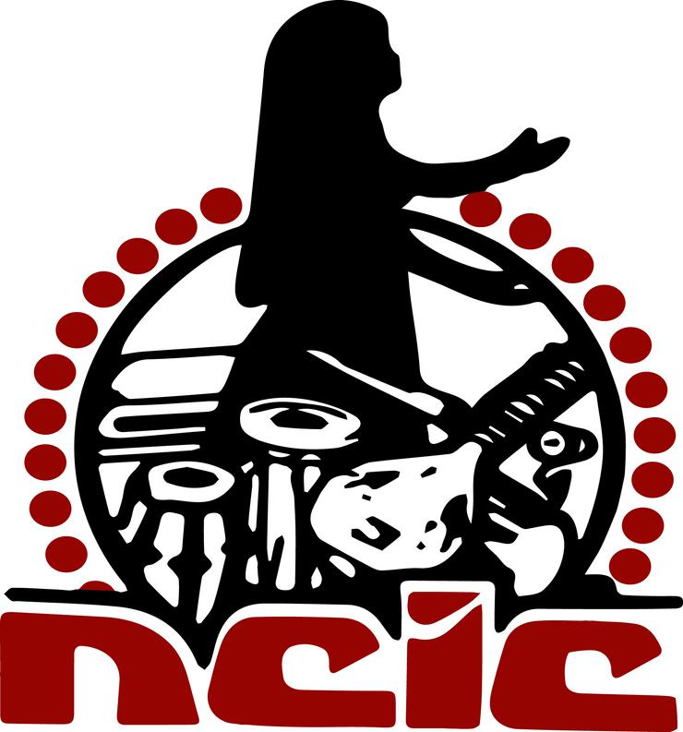

NATIONAL COUNCIL OF INDIAN CULTURE
HERITAGE CENTER
FIRST INTERNATIONAL PHAGWA CONFERENCE 2021
Phagwa in the Global Village:
Traditions, Innovations and Future Developments
FIPC2021
NCIC Nagar, 28-38 Narsaloo Ramaya Marg, Endeavour, Chaguanas 502128, Trinidad, W.I.

Tel/Fax: (868) 671-6242 / 789-9101 Email: phagwafipc2021@gmail.com; pgoopta@hotmail.com;

Website: http://www.ncictt.com

CONFERENCE ZOOM LINK : http://phagwa.ncictt.com/

MEDIA RELEASE

NCIC TO HOST FIRST INTERNATIONAL VIRTUAL PHAGWA CONFERENCE IN MARCH 2021

The National Council of Indian Culture (NCIC) will host the First International Virtual Phagwa Conference in Trinidad on Saturday 13th to Sunday 14th March 2021 at our headquarters, NCIC Nagar, 28-38 Narsaloo Ramaya Marg, Endeavour Road,Chaguanas.
This is the first time that such a Phagwa conference is being hosted in any part of the world.

The Phagwa (Holi) festival has been an integral part of the lives of Diasporic Indians the world over. While it has gained in popularity over the years, few efforts have been made to study this festival from an academic standpoint.

Phagwa is a Hindu festival celebrating the end of the dreary winter and the onset of spring in India in the month of Phagun in the Hindu calendar. In urban India it is called Holi while in most parts of the Diaspora it is called Phagwa It is observed in the month of March and the day is marked by fun and merriment as celebrants spray a red liquid dye (abir) on each other. For the Phagwa Festival, some conventional barriers are abandoned and songs like Hori, Dhrupad, Thumri, Kajri, Basant, Ulaaraa, and Chowtaal are sung as celebrants dance and rejoice at open-air venues. Apart from national celebrations in India, it is celebrated annually in most areas of the Indian Diaspora in North America, Europe, New Zealand, Fiji, Mauritius, South Africa, Guyana, Suriname, Aruba, Curacao, Grenada, Jamaica and Trinidad and Tobago and other areas where Indians have settled. In Guyana, it is observed as a public holiday.
The conference aims to bring together scholars and researchers to engage in global dialogue on the Phagwa Festival and to create a wider awareness of the festival.
Sixty-five (65)scholars and researchers from India, Fiji, Mauritius, South Africa, Suriname, Guyana, USA, Jamaica, Trinidad and Tobago, and other Diaspora countries would present their findings in thirteen (13) panels during the conference.
The conference will be hosted in its entirety via Zoom from 8 a.m. on both days and anyone is free to attend signing in with the following link-http://phagwa.ncictt.com/
For further information kindly contact the Conference Chairman Dr. Primnath Gooptar at +1 (868) 470-0133 or Ms Sarika Boodoo at +1 (868) 769-4142.

Respectfully,

Surujdeo Mangaroo
Public Relations Officer,
National Council of Indian Culture,
28-38 Narsaloo Ramaya Marg
Endeavor Road,
Chaguanas,
Trinidad & Tobago.
+18683898425
smangaroo58@gmail.com
tibl1@yahoo.com

